COUNCIL ASSESSMENT REPORT
Panel Reference | PPSHCC-21
DA number | DA/1692/2019
LGA | Lake Macquarie City Council
Proposed development | Seniors Housing (Residential Care Facility)
Street address | 36 Laycock Street, CAREY BAY NSW 2283
Applicant/Owner | Anglicare c/o deWitt Consulting  Anglicare
Date of DA lodgement | 22 November 2019
Number of submissions | One
Recommendation | Approval, subject to conditions of consent
Regional Development Criteria (Schedule 7 of the SEPP (State and Regional Development) 2011 | General development over $30 million
List of all relevant s4.15(1)(a) matters | - Lake Macquarie Local Environmental Plan 2014  - State Environmental Planning Policy (Housing for Seniors or People with a Disability) 2004  - State Environmental Planning Policy (State and Regional Development) 2011  - State Environmental Planning Policy (Coastal Management) 2018  - State Environmental Planning Policy No 55—Remediation of Land  - State Environmental Planning Policy No. 64 – Advertising and Signage  - Lake Macquarie Development Control Plan 2014
List all documents submitted with this report for the Panel’s consideration | Attachment 1: Architectural Plans  Attachment 2: Landscape Plans  Attachment 3: Engineering Plans  Attachment 4: Written Submission – Clause 4.6 Exception  Attachment 5: Draft Conditions of Consent
Clause 4.6 request/s | An exception to development standards is requested in relation to the maximum building height set under LMLEP 2014 clause 4.3.
Report prepared by | Jonathan Ford, Development Planner
Report date | Tuesday 30 June 2020

Summary of s4.15 matters  Have all recommendations in relation to relevant s4.15 matters been summarised in the Executive Summary of the assessment report? | Yes
Legislative clauses requiring consent authority satisfaction  Have relevant clauses in all applicable environmental planning instruments where the consent authority must be satisfied about a particular matter been listed, and relevant recommendations summarized, in the Executive Summary of the assessment report? | Yes
Clause 4.6 Exceptions to development standards  If a written request for a contravention to a development standard (clause 4.6 of the LEP) has been received, has it been attached to the assessment report? | Yes
Special Infrastructure Contributions  Does the DA require Special Infrastructure Contributions conditions (S7.24)? | No
Conditions  Have draft conditions been provided to the applicant for comment? | Yes

Assessment Report
Development Application (DA/1692/2019)
Proposal: Seniors Housing (Residential Care Facility)
Address: 36 Laycock Street, Carey Bay
Lot 200 DP 731318
Applicant: Anglicare c/o deWitt Consulting
Owner: Anglicare
Lodged: 22 November 2019
Zoning: R3 Medium Density Residential
Integrated Authority: NSW Rural Fire Service
CIV: $33,636,000
Assessing Officer: Jonathan Ford, Development Planner
Recommendation: Approval

Executive summary
This report assesses the proposal against relevant State, Regional and Local Environmental Planning Instruments and Policies, in accordance with Section 4.15(1) of the Environmental Planning and Assessment Act, 1979.
The application proposes construction of a Residential Care Facility (RCF) at the site comprising 126 beds and ancillary facilities and works.
The site maintains an existing seniors housing development, and the development provides a well-designed building that complements the existing use of the site.
The development has demonstrated compliance with the SEPP Housing for Seniors or People with a Disability 2004 (Seniors Housing SEPP) and provides good amenity and facilities for future residents of the facility.
The site maintains existing vegetation, some of which are proposed to be removed within the development area. The application has demonstrated appropriate replanting and ecological outcomes. Tree removal has been minimised, and the remnant vegetation corridor intersecting the site is to be enhanced with additional canopy tree planting.
The application proposes a variation to the building height standards under Clause 4.3 of the Lake Macquarie Local Environmental Plan 2014 up to 33%. The proposed variation is supported as the development has demonstrated consistency with the necessary heads of consideration under Clause 4.6 Exceptions to development standards.
The application has demonstrated appropriate visual outcomes by incorporating suitable design elements and landscaping to screen and soften the building form. The building is considered to be of sound design, suitably responsive to the scenic character of the site and surrounds.
The application is found to be in the public interest
Reasons for determination
The development has been assessed against the matters for consideration that apply to the land to which the development application relates as outlined in Section 4.15 of the Environmental Planning and Assessment Act, 1979 as follows:
- the development meets the requirements of the Lake Macquarie Local Environmental Plan 2014 and other relevant environmental planning instruments, inclusive of a Clause 4.6 Submission exception to the development standard under Clause 4.3 Height of buildings;
- consideration has been given to proposed instruments which have been the subject of public consultation;
- the development generally complies with Lake Macquarie Development Control Plan 2014 with any variations to the controls outlined and justified within this assessment report;
- no planning agreement / draft planning agreement is known to apply to the land;
- considering the likely impacts of the development on the natural and built environments, the development is considered to provide balanced and appropriate outcomes;
- the suitability of the site for the development, including characteristics and constraints of the land have been considered and it was found the land as being suitable for the development;
- matters of public interest have been considered in relation to social, economic and environmental outcomes.
Based on the balance of the matters considered, the development application is recommended for approval. Details of the assessment are contained in the assessment report below.
Community interest
The assessment of the proposed development under Section 4.15(1) of the Environmental Planning and Assessment Act, 1979 has considered the community views. The development application was notified in accordance with the Development Notification Requirements outlined in Section 1.15 of Part 1 of Council’s Development Control Plan 2014 as adopted by Lake Macquarie City Council.
From the notification period, one public submission was received in relation to the proposed development. The matters raised in this submission were considered as part of the assessment of the proposed development. For detailed comment regarding the matters raised in the submission refer to Section 4.15(1)(d) of this report.
Site, context and development history
The site maintains an existing seniors housing development which accommodates 91 RCF beds and 31 independent living dwellings.
The site has frontage to Laycock Street and Coal Point Road, however no element of the complex fronts Coal Point road due the existence of a steep ridgeline along this frontage.
The site has an area of 2.4 hectares.
The site is located on the lower side of a natural ridgeline to the south-west and slopes from the south-west corner to the north-east corner.
The site maintains a mixture of exotic and native vegetation, interspersed throughout existing residential accommodation. The site is adjoined by approximately 1.2h hectares of bushland to the southeast, which continues as a remnant corridor along the eastern site boundary. The corridor was identified by Council as being ecologically significant in pre-lodgement discussions.
The site is bounded by low and medium scale residential development comprising a mixture of detached housing and townhouses. A local commercial centre is located to the north-east of the site on the opposite side of Laycock Street.
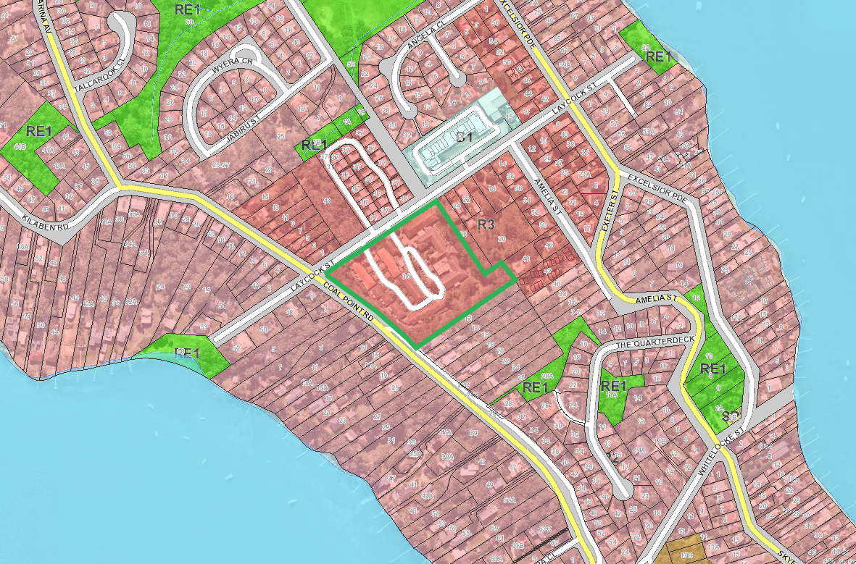Figure 1: Map of site and surrounding land uses and zones (site outlined in green)
Pre-lodgement consultation was undertaken with Council in September 2019 for a RCF reflective of that proposed in the current application. Key items discussed include
- The remnant ecological corridor along the north-east site boundary
- Building height, scale and setbacks
- Non-discriminatory access
- Bushfire risk
- Visual impacts
The proposed development is considered to reasonably respond to the matters identified by Council in pre-lodgement discussions.
Proposal
The application proposes construction of a Residential Care Facility (RCF) (a form of Seniors Housing) at the site.
The development will operate in conjunction with the existing operations of the site as a Seniors Housing development managed by Anglicare.
The proposal includes a two storey building shaped in a winged arrangement containing 126 beds for residential aged care and ancillary facilities.
The building includes:
- semi-basement car parking including 53 spaces (including non-discriminatory and ambulance parking), 12 at grade car parking spaces and driveway;
- entry / administration area, including new reception, offices, meeting rooms amenities, etc;
- day therapy areas, including gym, salon, prayer room, treatment room, etc;
- common areas including lounge, dining, activities rooms, etc;
- back of house areas including service kitchen, cool room, store rooms, IT/Comms room and electrical switchroom, waste storage, etc;
- staff areas and amenities;
- café;
To facilitate the development, demolition of the existing residential aged care facility will be undertaken.
The applicant has specified that transitional arrangements are in place to allow continuous care for affected residents.
The new facility will provide an additional 35 beds.
The application also proposes site works including earthworks, stormwater infrastructure and landscaping.
Detailed Assessment

Environmental Planning and Assessment Act 1979
Applicable State, Regional and Local Environmental Planning Instruments and Policies are detailed hereunder. Where not explicitly detailed, it is considered those instruments or policies are not relevant to the proposal.

Section 4.15: Potential matters for consideration

Section 4.15 (1) (a) (i) the provisions of any EPI’s
State Environmental Planning Policy (State and Regional Development)
In accordance with Schedule 7 and Part 4 (Regionally significant development) of the SEPP, the development comprises general development over $30 million and is therefore regionally significant development. The Hunter and Central Coast Regional Planning Panel will determine the development application.
State Environmental Planning Policy (Housing for Seniors or People with a Disability) 2004
The application proposes to construct a Residential Care Facility (a form of Seniors Housing).
In accordance with Clause 4, the policy applies to land that is zoned for urban purposes and permits residential flat buildings. The site is zoned R3 Medium Density Residential and in accordance with Lake Macquarie Local Environmental Plan 2014 (LMLEP 2014) residential flat building development is permitted in the zone. The development is permitted in accordance with Seniors Housing SEPP.
SEPP Seniors and LMLEP provide the following definition for a Residential Care Facility:
residential care facility is residential accommodation for seniors or people with a disability that includes—
(a) meals and cleaning services, and
(b) personal care or nursing care, or both, and
(c) appropriate staffing, furniture, furnishings and equipment for the provision of that accommodation and care,
not being a dwelling, hostel, hospital or psychiatric facility.
Submitted documentation indicates the proposal aligns with the above definition. Additional land uses proposed within the development (e.g. food service, administration, gym etc) are considered ancillary to the RCF.
The Seniors Housing SEPP contains a number of matters of consideration / design criteria, which have been detailed in the table below.
It is noted the Seniors Housing SEPP also contains a number of provisions such as bushfire, water and sewer, neighbourhood amenity and streetscape, car parking, visual and acoustic privacy, solar access, stormwater, crime prevention, accessibility, waste management, and the like that are not detailed in the table below, these matters are detailed elsewhere in this report.

Table 1: Seniors Housing SEPP assessment table
Key Standards | Control / design criteria | Complies  Yes / No | Comment
11 Residential care facilities | Residential accommodation for seniors or people with a disability that includes:  - meals and cleaning services, and  - personal care or nursing care, or both, and  - appropriate staffing, furniture, furnishings and equipment for the provision of that accommodation and care | Yes | The development includes the provision of meals (prepared on-site), 28 care staff, personal care, cleaning services and the provision of furniture and furnishings to the facility.  The proposal can therefore be classified as a residential aged care facility.  The ongoing provision of these services is managed under the Aged Care Act 1997.
18 Restrictions on occupation of seniors housing allowed under this Chapter | Clause 18 of the policy requires Council to impose a condition that restricts the occupation of the development for seniors and persons with a disability, and staff employed in associated with the development.  This can be achieved by way of a restriction as to user registered against the title of the property. | Yes | A condition of consent will be imposed to ensure this outcome is achieved.
26 Location and access to facilities | Residents must have access to:  - shops, bank service providers and other retail and commercial services that residents may reasonably require, and  - community services and recreation facilities, and  - the practice of a general medical practitioner.  Access must be:  - if within 400 metres  - access ways are accessible;  - is available both to and from the development during daylight hours at least once each day from Monday to Friday (both days inclusive),  - if not within 400 metres  - a transport service from the site is available to residents, and  - it takes residents to within 400 metres from required services, and;  - a bus capable of carrying at least 10 passengers must be provided;  - the service is available to and from the development during daylight hours at least once each day from Monday to Friday (both days inclusive), and  - any access to the service is via accessible pathways. | Yes | The applicant’s statement of environmental effects indicates that sufficient facilities will be available to residents of the development.  Neighbourhood shops are proximate to the site (within 400m), and the applicant has indicated a shuttle bus service for residents is to be provided.  Public transport services (buses) are available to the development. Route 274 provides access to the nearest expansive commercial centre (Toronto City Centre). Current stops are within 400m of the development site, from Coal Point Road and Skye Point Road, however the grades are likely higher than the provisions of this clause. In this regard it is noted:  - The complex is a relatively ‘high care’ environment where independent journeys are unlikely;  - A private shuttle service is to be provided for residents;  - Access and proximity to services is considered to be satisfactory.
29 Consent authority to consider certain site compatibility criteria for development applications to which Clause 24 does not apply | The site/development does not require a Site Compatibility Certificate (SCC) under Clause 24.  Where an SCC is not required, Council must give consideration to whether the development is compatible with the surrounding land uses and:  - the natural environment and the existing and approved uses of land in the vicinity;  - the services and infrastructure that are, or will be available to meet the demands arising from the proposed development (particularly, retail, community, medical and transport services);  - the bulk, scale, built form and character of the proposed development and impact to existing and approved uses. | Yes | Natural environment  The development generally confirms to existing, disturbed areas of the site.  Ecologically significant vegetation is retained and enhanced through landscaping provisions.  Infrastructure  The development is proximate to nearby commercial and retail land, with sufficient access through public transport and an internal bus service.  Design outcomes  The bulk and scale of the proposal is considered satisfactory for the medium density residential context.
40 Development Standards – minimum sizes and building height | Development standards to be complied with:  - The size of the site must be at least 1,000m²;  - The site frontage must be at least 20 metres wide measured at the building line; | Yes | The site has an area in excess of 1000m² and frontage in excess of 20 metres.
48 Standards that cannot be used to refuse development consent for residential care facilities | Consent must not be refused for a residential care facility on any of the following grounds:  - building height: if all proposed buildings are 8 metres or less in height (and regardless of any other standard specified by another environmental planning instrument limiting development to 2 storeys) | No | The development exceeds the 8m allowance provided under this clause.  Further assessment regarding building height is provided under Clause 4.6 of LMLEP in this report.
 | - density and scale: if the density and scale of the buildings when expressed as a floor space ratio (FSR) is 1:1 or less | Yes | The application proposes approximately 7200m² of floor area.  Given the extensive area of the site, the additional floor area would not result in the development exceeding an FSR of 1:1.
 | - landscaped area: if a minimum of 25 square metres of landscaped area per residential care facility bed is provided | Yes | The application proposes 126 beds and a landscape area of 3150m² is required.  The application proposes a landscape area well in excess of this requirement across the site.
 | - parking for residents and visitors: if at least the following is provided:  - 1 parking space for each 10 beds in the residential care facility  - or 1 parking space for each 15 beds if the facility provides care only for persons with dementia; and  - 1 parking space for each 2 persons to be employed in connection with the development and on duty at any one time, and  - 1 parking space suitable for an ambulance. | Yes | The development provides 126 beds, with up to 28 staff on site, resulting in a minimum car parking requirement of 27.6 spaces.  It is noted that a non-discriminatory space is also required in accordance with Council’s DCP and the Building Code of Australia.  The application proposes the following:  - 53 spaces within the basement, 30 of which are secured staff spaces. The remaining basement spaces are provided for visitors, with two non-discriminatory spaces included;  - 12 at grade visitor spaces, including two non-discriminatory spaces;  - A porte cochere drop-off area and designated ambulance parking bay at the building entrance.  The development provides a compliant allocation of car parking.
55 Residential care facilities for seniors required to have fire sprinkler systems | Consent must not be granted for a residential care facility unless the proposed development includes a fire sprinkler system. | Yes | Conditions will be imposed to ensure a fire sprinkler system is installed.

State Environmental Planning Policy (Coastal Management) 2018
The site is located within the Coastal Environment Area and partially within the Coastal Use Area. Matters for consideration are provided under Clause 13 and 14 respectively.
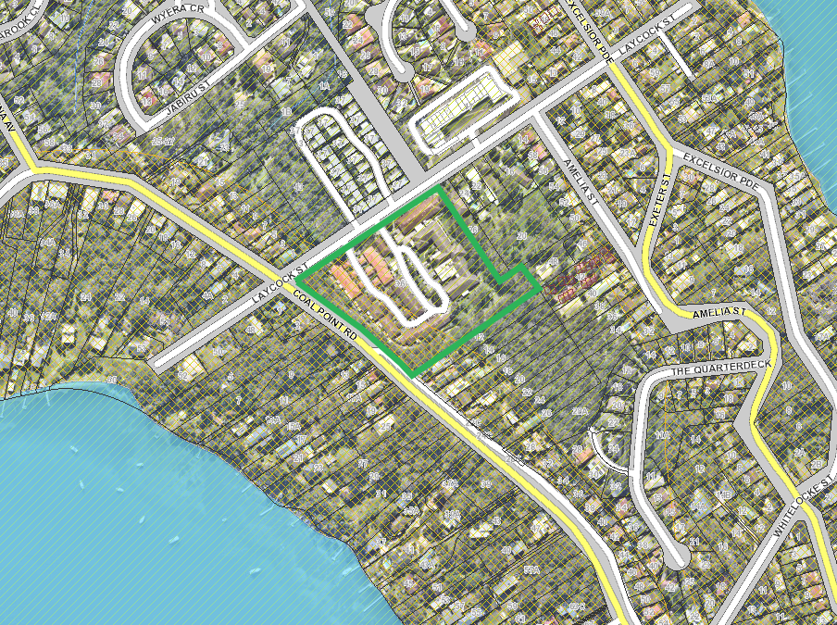
Figure 2: Coastal use and coastal environment area extent
The development is considered consistent with the SEPP and will not have adverse impacts to the coastal zone in terms of coastal values, natural coastal processes, access to coast and foreshore areas, impact to marine vegetation, aboriginal heritage, scenic quality, etc. Specific details of these relevant matters are discussed throughout this report.
The policy also states consent must not be granted to development on land within the coastal zone unless the consent authority has taken into consideration the relevant provisions of a coastal management program that applies to the land. The site is subject to the LMCC Coastal Zone Management Plan. The Plan does not have any specific matters relating to the site and the overall objectives of the Plan would apply; as discussed, these overall objectives for development in the coastal zone have been achieved.

State Environmental Planning Policy No. 44 – Koala Habitat Protection
Refer to assessment under DCP 2014 Part 3 Section 2.12 Flora and Fauna.

State Environmental Planning Policy No 55—Remediation of Land
Refer to assessment under DCP 2014 Part 3 Section 2.5 Contaminated land.

Lake Macquarie Local Environmental Plan 2014
Clause 2.3 Zone objectives and Land Use Table
The development is permitted both under Seniors Housing SEPP and LMLEP 2014. The application has been applied for under the Seniors Housing SEPP. Refer to Seniors Housing SEPP within this report for further consideration of permissibility.
The site is zoned R3 Medium Density Residential. The proposal is considered to be consistent with the relevant objectives of the zone as follows,
- To provide for the housing needs of the community within a medium density residential environment.
- To maintain and enhance the residential amenity and character of the surrounding area.
The development is considered consistent with the zone objectives, in that the building form has been designed to be sympathetic to the site’s natural attributes, and the surrounding residential land uses. The development has been designed to maintain the residential amenity and nature of the medium density residential within the surrounds of the site.
The development provides a seniors housing development that provides additional residential care housing options for the community.
Other proposed uses (e.g. café) are ancillary to the dominant function of the site for seniors housing, and are therefore permitted.
Clause 2.7 Demolition requires development consent
The application proposes demolition and has sought consent for these works.
Clause 4.3 Height of buildings
The site is subject to a 10 metre building height limit.
The application proposes a maximum building height of 13.3 metres above existing ground level. This results in a variation to the standard of 3.3 metres (33%).
For consideration of this matter, refer to assessment under LMLEP 2014 - Clause 4.6.
Clause 4.6 Exceptions to Development Standards
A Clause 4.6 Exception to development standard has been submitted with the application for variation to Clause 4.3 of LMLEP 2014 (Height of buildings).
The application proposes a maximum building height of 13.3 metres above existing ground level. A maximum variation to the standard of 3.3 metres (33%) is proposed, which relates to the following portions of the second floor roof (refer to Figure 3):
- southern wing: 1.8 metre exceedance;
- north east wing: 3.21 metre exceedance,
- north west wing: 3.31 metre exceedance, and
The height exceedance is most prominent at the front (northern) aspect, with rear southern portions of the building generally in compliance with the height standard. The area of exceedance follows the contours of the natural ground level, which drops off steeply upon approaching Laycock Street.
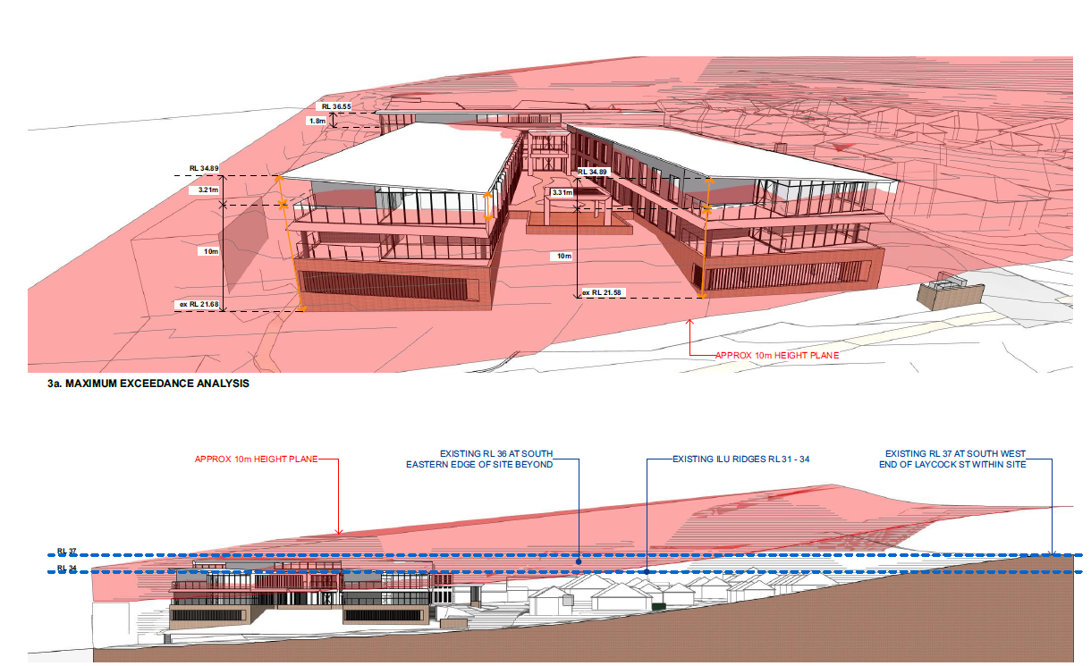
Figure 3: Building height variation to 10 meter LEP building height
Development consent must not be granted for development that contravenes a development standard unless the consent authority has considered a written request from the applicant that seeks to justify the contravention of the development standard by demonstrating,
- that compliance with the development standard is unreasonable or unnecessary in the circumstances of the case, and
- that there are sufficient environmental planning grounds to justify contravening the development standard.
The applicant’s written variations have argued the objectives of the building height development standards are achieved notwithstanding non-compliance with the applicable standards. In particular, the written variations have argued the height of the building is appropriate for its location and is a high quality urban form (clause 4.3 LMLEP 2014) and sits comfortably in the low-density residential zone (Seniors Housing SEPP) for the following reasons:
- Due to the nature of the development, consistent finished floor levels are crucial. Incorporation of a split-level design is not feasible;
- The building steps with the existing contours of the development area and the extent of cut has been deliberately minimised which has resulted in some of the height exceedances.
- The positioning of the basement allows for minimal land disturbance. Repositioning the basement to an area with a higher natural ground level would result in more substantial earthworks;
- The bulk and scale of the development, including elements that exceed the building height standard is appropriate for the site and locality, as demonstrated by submitted visual analysis.
- Extensive landscaping will be planted around the building to soften and visually fragment the building;
- The height of the building is consistent with the character of existing built form within the existing site;
- The building has suitable separation from existing residences on the site, and adjoining sites, and the elements of the building that exceed the building height standard do not have any adverse amenity impacts on existing residents including solar access and visual privacy;
- The building has been designed with appropriate floor to ceiling heights to provide good amenity to residents’ and communal areas, and
Council consider the applicant’s clause 4.6 variations have articulated appropriately that compliance with the development standard is unreasonable or unnecessary in the circumstances of the case, and there are sufficient environmental planning grounds to justify contravening the development standard.
In consideration of the clause 4.6 variations, Council have considered the development will be in the public interest because;
- it is consistent with the objectives of the building height standards; and
- is consistent with the objectives of the R3 Low Density Residential zone.
Consideration also needs to be given to whether the variation raises any matter of significance for state or regional environmental planning, and the public benefit of maintaining the standard.
The objectives of the clause 4.3 height of buildings in LMLEP 2014 are to ensure the height of buildings is appropriate for their location, and to permit building heights that encourage high quality urban form.
For those reasons specified above by the applicant, the development is consistent with the building height standards. Particularly, the building height variation would be unperceivable in the context of the overall building form, and the variation is considered minor and not have adverse visual or amenity impacts.
With respect to the development being consistent with the objectives of the zone, as previously discussed the development is consistent with the R3 Low Density Residential zone as it provides a building form designed to maintain and enhance the residential amenity and character of the surrounding area.
The development provides a seniors housing development in a well-serviced location, and is co-located with existing seniors housing to provide additional residential care housing options for the community.
In this regard, the development is consistent with the objectives of the building height standards and zone objectives and is in the public interest.
The variation does not raise any matters of state or regional significance. Further, there is no public benefit in maintaining strict compliance with the building height standard given no unreasonable impacts result from the variation.
As the consent authority for the development application, the Hunter and Central Coast Regional Planning Panel have delegation to determine the clause 4.6 variations.
Clause 7.1 Acid sulfate soils
Refer to assessment under DCP 2014 Part 3 Section 2.6 Acid sulfate soils.
Clause 7.2 Earthworks
Refer to assessment under DCP 2014 Part 3 Section 4.14 Cut and fill.
Clause 7.21 Essential services
Utilities required for the development are to be incorporated into the design, screened behind a brick element within the front setback.
The site has sufficient servicing of reticulated water for residential use and firefighting purposes.
The application was submitted to Hunter Water Corporation (HWC) prior to lodgement. Hunter Water identified water and sewer connection is available to the site.
For consideration of stormwater drainage and vehicle access refer to assessment under DCP 2014 Part 3 Section 2.7 Stormwater Management and Section 4.7 Traffic and Transport.

Section 4.15 (1) (a) (ii) the provisions of any draft EPI

State Environmental Planning Policy (Koala Habitat Protection) 2019

The Policy has been gazetted since the lodgement of the application. Refer to assessment under DCP 2014 Part 3 Section 2.12 Flora and Fauna.

Section 4.15 (1) (a) (iii) DCP’s
Lake Macquarie Development Control Plan (DCP) 2014
Part 3 – Development in Residential Zones
2.1 Site analysis
A site analysis plan and documentation was submitted with the application.
SEPP (Housing for Seniors or People with a Disability) also contains provisions for site analysis documentation.
2.2 Scenic values
A visual impact assessment (VIA) has been submitted which includes photomontages of the development viewed from Laycock Street (north, east and west).
The VIA identifies the development has incorporated suitable design outcomes and landscaping to mitigate impacts to surrounding residences.
The VIA has considered the visual impact of the development from the western approach along Laycock Street. As demonstrated in Figure 4, the development will not block views to the lake, and does not protrude above the existing tree line on adjacent sites.
Council’s Landscape Architect is supportive of the development and visual impact, subject to the proposed landscaping being implemented. A condition of consent is recommended to ensure the landscape outcomes are achieved.
Figure 4: Photomontage view of western approach to the development along Laycock Street

Figure 5: Photomontage view of eastern approach from adjoining shops / townhouses
2.4 Mine subsidence
The site is located within a mine subsidence district and is subject to Guideline 8 of the Subsidence Advisory NSW Surface Development Guidelines.
Guideline 8 imposes no restrictions on development.
2.5 Contaminated land
The site has historically been utilised for seniors housing. The site is not identified as being contaminated or potentially contaminated.
A Phase 2 Contamination Assessment was submitted with the application. The assessment identifies minor amounts of builder’s rubble within existing fill on site, which will require remediation. The assessment recommends a Remediation Action Plan and Unexpected Finds Protocol for the site / development.
Council has reviewed the report and supports the development, subject to conditions of consent regarding remediation and validation of the land.
2.6 Acid sulfate soils
The site is mapped within a Class 5 acid sulfate soils area.
The development does not propose works which are likely to lower the water table and therefore impact upon any acid sulfate soils present within 500 metres.
2.7 Stormwater management
A stormwater management plan has been submitted with the application. The plan includes:
- capturing of roof water and direction to rainwater tank via downpipes;
- installation of 118m³ on-site detention;
- pit and pipe drainage to new vehicle access, and to capture existing roadway drainage and direct around the building;
- discharge to Laycock street via existing drainage infrastructure.
Council has reviewed the design and is supportive of the stormwater management scheme.
SEPP (Housing for Seniors or People with a Disability) also contains requirements for stormwater management. The proposal complies with these requirements by controlling and minimising impacts of stormwater runoff to adjoining properties and receiving waters, and providing stormwater detention and re-use.
2.11 Bushfire
The site is bushfire prone. Bushfire threats comprise vegetation upslope to the south-east of the development, some of which is located on the site.
A Bushfire Assessment Report has been submitted.
The application was referred to NSW RFS as Integrated Development (Seniors Housing is captured as a special fire protection purpose). NSW RFS supported the development in granting a Bush Fire Safety Authority and providing General Terms of Approval in relation to Asset Protection Zones (APZs), water and utility provision, access, evacuation plan, construction requirements, and landscaping requirements.
The above is achievable within the development.
SEPP (Housing for Seniors or People with a Disability) also contains requirements for bushfire outcomes. This includes the need to consider surrounding land uses and population groups and the capacity of existing facilities and roadways to cater for evacuation during a bushfire event. The policy requires consultation with the NSW RFS. These outcomes have been addressed by way of referral to the NSW RFS as detailed above.
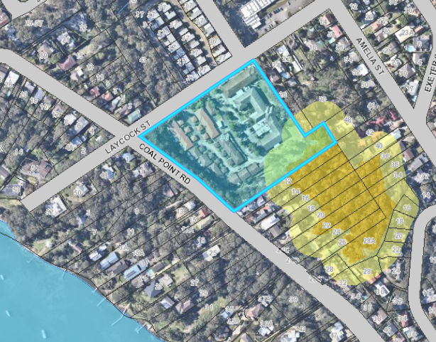
Figure 6: Bushfire map
2.12 Flora and fauna and 2.13 Preservation of trees and vegetation
An Ecological Assessment Report and Arborist Report have been submitted.
The site has approximately 0.75 hectares of partially cleared remnant native vegetation reflective of the common vegetation community Lake Macquarie Spotted Gum Forest. The extent of mapped native vegetation on site occurs along the eastern, southern and western boundaries and will not be significantly impacted by the proposal.
Council’s Arborist is satisfied with the Arborist report submitted and recommendations made within the report. Conditions of consent are recommended to ensure implementation of the recommendations of the report.
The Arborist Report identifies that 13 native trees are proposed to be removed (refer to tree removal and retention plan) due to their location within the building footprint (including earthworks and roadworks) or poor health. A series of exotic trees are also proposed to be removed and can be removed without development consent. No hollow bearing trees are proposed for removal. Tree protection zones (TPZ) will be implemented for any trees to be retained.
Council’s Flora and Fauna officer identified that the site provides habitat to a number of threatened species including Wallangarra White Gum (Eucalyptus Scoparia) and
Grey-headed Flying-fox (Pteropus poliocephalus). The Wallangarra White Gum on site is identified as tree 173 on the submitted arborists report, which is noted as potentially requiring removal due to its proximity to the proposed works. Council’s Tree Officer and Flora and Fauna Officer have concurred that removal of this tree is acceptable, noting that it is already experiencing declining health and that it is not a native species to the Lake Macquarie area. The tree was likely planted as a landscaping provision for the facility.
Council’s Flora and Fauna Officer has advised that no significant impact is otherwise likely to occur on any threatened species as the development due to the relatively modest extent of clearing, additional planting and retention of ecological corridors. Conditions of consent are recommended to ensure the implementation of the recommendations of the Ecology Assessment Report.
The Ecological Assessment Report has considered the development / site against the provisions of SEPP 44. The document has indicated the site comprises potential Koala habitat however does not comprise core koala habitat.
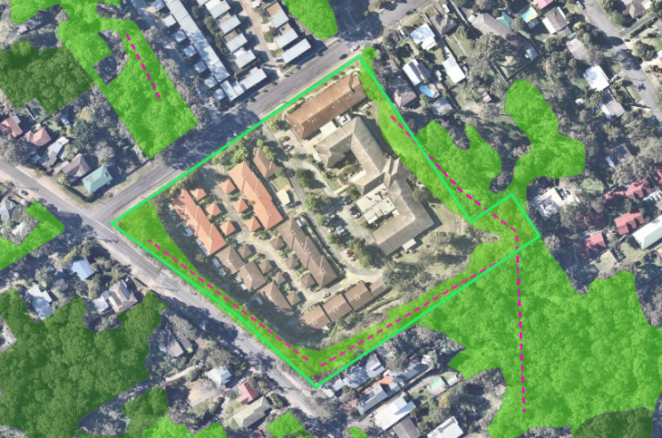

Figure 7: LMCC Native vegetation mapping (2011)
2.17 Social impact
Council’s Social Planner is generally supportive of the development and acknowledges the social benefit the development will have on the ageing demographic of the Lake Macquarie.
The officer supports the transitional arrangements for existing residents that will be put in place during the construction of the development.
2.18 Economic impact
The development is a permitted form of development for the zone, and thus provides an expected development outcome.
Whilst the value of the development exceeds $5 million, it is considered an economic impact assessment is not necessary in this instance as the proposal reflects the existing development of the site.
2.20 Services
Refer to assessment under LMLEP 2014 Clause 7.21 Essential services.
3.1 Streetscape, 3.6 Building bulk and 3.8 Roofs
The site has extensive frontage to Laycock Street, internal roadways and existing residences.
The proposal provides acceptable streetscape outcomes. The building has been designed to reflect the existing use of the site for seniors housing development, and current building trends for RAF development.
In particular:
- The proposal sits appropriately within the built form of the site and surrounds. The scale and density of the proposal is considered appropriate given the medium density zoning of the subject lot and existing and future development of surrounding land;
- The principal pedestrian entrance is visible to the street being located parallel to the driveway entry, with crossing points to the main building entrance. An additional pedestrian accessway is also provided along the north-eastern site boundary;
- The design allows for passive surveillance to Laycock Street via balconies and the communal courtyard. Windows and balconies also provide partial surveillance of the new pedestrian routes;
- Utilities required for the proposal are to be incorporated into the design, screened behind the brick entry wall within the front setback area;
- Facades of the building includes sufficient variation in materials and features so as to avoid excessive presentation of blank walls. The winged design of the development allows for a less bulky presentation to Laycock Street;
- Landscaping treatments within the front setback effectively screen the raised basement car parking element of the building;
- Generous landscaping is provided in the front setback area with the inclusion of a batter and informal rock wall to ensure long-term viability of the proposed planting;
3.2 Street setback, 3.3 Side setback and 3.4 Rear setback
The application proposes a street setback that varies from 4 metres for the north-western wing, up to 8.2 metres for the north-eastern wing. This setback incorporates a landscaping buffer to screen the basement wall elevation of the building.
Surrounding development has a variety of street setbacks as demonstrated in Figure 8. The existing building on site to be demolished has a 6 metre street setback.
The street setback is considered appropriate as sufficient setback from the street is provided to ensure an appropriate bulk and scale of the building is achieved when viewed from the street. The winged design of the building allows for a less substantive street wall presentation.
The staggered setback enables the building to be complementary to the existing dwelling’s setback at 26 Laycock Street.
Setbacks to side and rear other boundaries meet or exceed Council’s requirements.
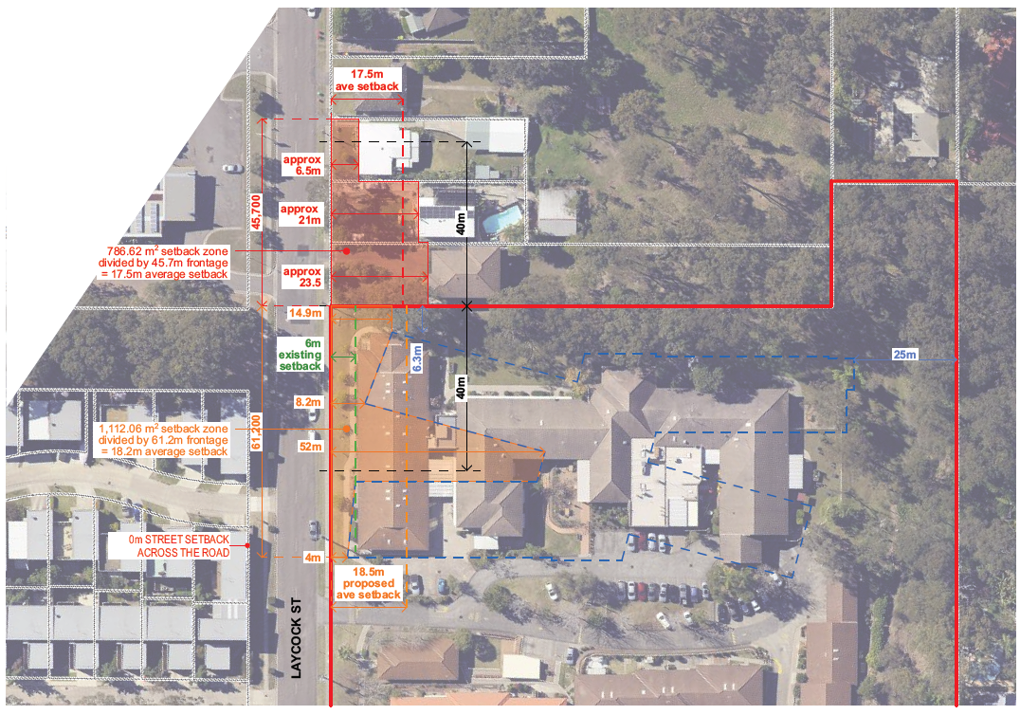
Figure 8: Street setback analysis for the site and locality
3.5 Site coverage
Refer to assessment under SEPP (Housing for Seniors or People with a Disability) Clause 48 Standards that cannot be used to refuse development consent for residential care facilities (floor space ratio).
3.9 Views
Due to the location of the site and the topography of the land, the development will not impact upon any significant views within the surrounding locality.
3.10 Solar access
The development will not overshadow any existing dwellings within the site.
With respect to solar access within the development, appropriate levels of solar access is achieved to rooms and communal living spaces (internal and external). Whilst some spaces may not receive optimal solar access, the variety of areas provides options for residents.
SEPP (Housing for Seniors or People with a Disability) also contains requirements for solar access.
Submitted shadow diagrams indicate minimal overshadowing impacts to adjoining lands, with the shadows cast confined predominately to the subject site.
3.11 Energy efficiency and generation
The development will be required to comply with Section J of the NCC whereby energy efficiency requirements apply.
4 Visual privacy
Visual privacy between rooms will be achieved by window treatments included as part of the facility fit out. The achievement of visual privacy is inherent to the development proposed.
Visual privacy to adjoining residences within the site has been achieved by way of separation.
Suitable separation is provided to any residences on adjoining lands, and minimal overlooking opportunities exist.
SEPP (Housing for Seniors or People with a Disability) also contains requirements for visual privacy.
4.1 Acoustic privacy
An Acoustic Report has been submitted with the application.
The report identifies acoustic amenity can be achieved to future and existing residents within the site, and on adjoining lands through:
- Sound insulation between floors and walls;
- Masonry construction where walls separate a laundry or kitchen;
- Back to back service points; and
- Separation of ducts / pipes from occupied rooms.

Conditions of consent are to be imposed with respect to Council requirements for internal comfort and noise generation.
SEPP (Housing for Seniors or People with a Disability) also contains requirements for acoustic privacy. The proposal complies with these requirements by ensuring appropriate noise levels are achieved within residential rooms.
4.2 Landscape area
Refer to assessment under SEPP (Housing for Seniors or People with a Disability) / Clause 48 Standards that cannot be used to refuse development consent for residential care facilities.
4.3 Landscape design
Landscaping plans have been submitted with the application demonstrating landscaping to the perimeter of, and within the building to provide softening/screening and amenity.
This plans include:
- native tree and understorey planting along the Laycock Street frontage to assist in visually screening the building;
- native tree planting to the northern boundary to assist screening and enhance the health of the remnant vegetation corridor;
- native tree and understorey planting around the building, and within the communal open space areas central to the building;
- retention of existing visually significant trees to the south-east of the building for visual and amenity purposes
Landscaping has taken into account bushfire restrictions that apply to the development and site.
Council’s Landscape Architect is supportive of the development and landscaping outcomes. The proposed landscaping outcomes will be achieved by way of conditions of consent and approved plans.
4.7 Traffic and Transport
The development is provided with access to Laycock Street via an existing entry/exit.
Works to the existing driveway include provision of new access points to the basement car park, as well as dedicated at grade parking, pedestrian crossings and turning areas.
Council’s Development Engineer is satisfied with the access and sight distances to/from Laycock Street.
Council’s Traffic Engineer has reviewed the potential impacts of the development to the local road network and is satisfied with the development.
4.8 Design of parking and service areas
The application proposes construction of a mixture of basement and at-grade car parking. A designated area for service vehicles has been provided.
Council’s Development Engineer is satisfied with the parking and service area design and has confirmed the internal driveway and car parking and service area comply with Council’s requirements and the applicable Australian Standards.
4.10 Motor bike parking and bicycle storage
Refer to assessment under SEPP (Housing for Seniors or People with a Disability) Clause 48 Standards that cannot be used to refuse development consent for residential care facilities.
4.11 Car parking rates
Refer to assessment under SEPP (Housing for Seniors or People with a Disability) Clause 48 Standards that cannot be used to refuse development consent for residential care facilities.
4.12 Non-discriminatory access
An Access Report has been submitted with the application.
The report identifies all requirements of the applicable Australian Standards are achievable with the development and specific details can be resolved at CC stage.
Council are satisfied with the proposed accessible outcomes and confirmed the premises is capable of complying with AS 1428.1 and the Premises Standard (which will be demonstrated at CC stage).
SEPP (Housing for Seniors or People with a Disability) also contains requirements for accessibility. The proposal complies with these requirements by having pedestrian links that provide access to public transport services or local facilities.
4.13 Safety and security
A CPTED report has been submitted with the application.
The report identifies the following findings and recommendations:
- building use and design achieves suitable surveillance (natural, passive and technical);
- access control measures will be provided to control access to/within the building;
- signage to be erected to direct paths of travel and also restricted areas of the site;
- appropriate landscaping and lighting implementation and maintenance.
Council officers are supportive of the proposal and support the recommendations of the CPTED report.
SEPP (Housing for Seniors or People with a Disability) also contains requirements for crime prevention. The proposal complies with these requirements by achieving appropriate surveillance.
4.14 Cut and Fill / 2.3 Geotechnical
The application proposes up to four metres of excavation, which relates to the basement car parking. The extent of cut enables car parking to be provided at basement level.
Filling works are also proposed up to a maximum of 3-4 metres, which relates to street setback landscaping buffer.
Earthworks are generally located within the building footprint and driveway. Where external to the building footprint, earthworks have been battered or appropriately retained and landscaped. Suitable landscaping will also be undertaken adjacent to any external retaining walls to further soften/screen any views to these structures.
Earthworks are sufficiently offset from site boundaries, and do not require the provision of any substantial retaining works that would be visible from the public domain or adjacent lots.
The extent of cut and fill is considered reasonable given the constraints of the site and development.
Council’s Engineer has reviewed, and is supportive of the proposed earthworks.
A geotechnical report has been submitted. Council’s Engineer supports the report and has recommended conditions of consent to ensure the recommendations of the report are implemented.
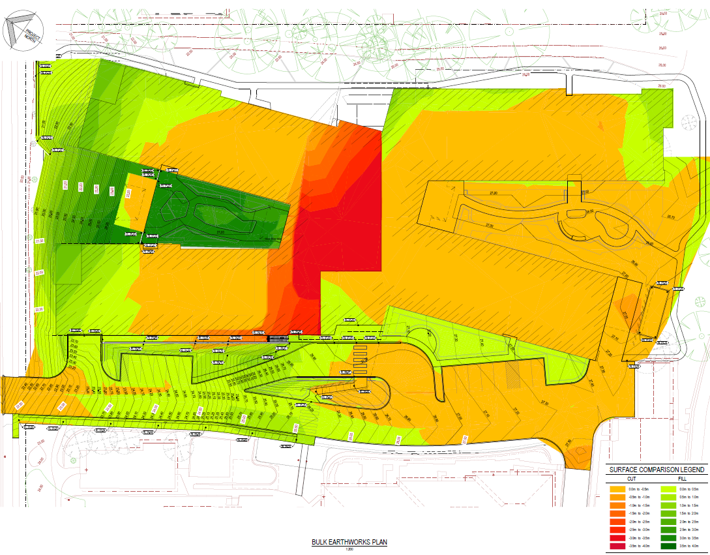
Figure 9: Bulk earthworks plan
5.1 Demolition and construction waste management
The application proposes demolition and construction works and wastes will be generated.
To ensure that any wastes are appropriately managed, a suitable condition of consent will be imposed.
5.2 Waste management and 5.4 Liquid trade waste and chemical storage
A waste management plan for the construction and operation of the development has been submitted. The plan details waste servicing as follows:
- a centralised waste storage area is to be utilised within the building; adjacent to the covered loading dock;
- all waste collection services and deliveries will be undertaken within the loading dock;
- specialist private waste collectors will be engaged to remove all generated waste. Waste streams include general waste, recyclables, paper/ cardboard, cytotoxic waste and general medical waste.
- waste collection will be undertaken during standard business hours to minimise noise impacts on residents, and
- maintenance staff will be responsible for the management and sorting of waste, and the maintenance of waste management equipment and spaces.
Council’s Waste Officer has reviewed and has no objection to the waste servicing given private waste contractors will be utilised.
SEPP (Housing for Seniors or People with a Disability) also contains requirements for waste management.
5.5 Erosion and Sediment Control
Erosion and sediment control plans have been submitted which are considered satisfactory by Council officers.
5.6 Air quality
No adverse impacts with regard to noise, dust or other emissions are expected from ongoing operation of the development.
A standard condition will be imposed to manage such impacts during construction.
5.7 Noise and Vibration
No adverse impacts with regard to noise, dust or other emissions are expected from construction of the development.
Conditions of consent will be imposed to manage such impacts during construction.

Section 4.15 (1) (a) (iv) any matters prescribed by the regulations
The application proposes demolition works. Conditions of consent will be imposed to ensure these works are undertaken in accordance with relevant standards.

Section 4.15 (1) (b) the likely impacts of the development

The likely impacts of the development contained in this part of the Act have been detailed throughout the assessment report.

Section 4.15 (1) (c) the suitability of the site for development

Does the proposal fit the locality?
The development is considered to fit the locality. The proposal provides outcomes that are consistent with the expected development of the site. Building form has been designed to respect existing seniors housing development on the site, and surrounding low density residential lands.

Are the site attributes conducive to development?
As demonstrated in this report, the site is conducive to the development proposed.

Section 4.15 (1) (d) any submissions made in accordance with this Act or the Regulations?

Public submissions
The application was notified in accordance with Council’s Policy from 27 November 2019 until 19 December 2019.
One submission in objection to the development was received. The objection appears to predominately relate to construction impacts.
As detailed in this report, conditions will be imposed to manage impacts associated with the construction of the development (i.e. dust, noise, construction vehicle movements, etc).

Section 4.15 (1) (e) the public interest
It is considered the proposed development is in the public interest. The application provides a development that is consistent with the zoning of the land and expected development of the site.
Whilst the application proposes a variation to the building height standards under LMLEP 2014, the development has demonstrated it is consistent with the objectives of the building heights standards and objectives of the R3 Medium Density Residential zone, and therefore in the public interest.
The application has demonstrated compliance with other relevant controls, and therefore demonstrated that no significant amenity impacts will arise, subject to the imposition and compliance with recommended conditions of consent.

Section 7.11 Contribution towards provision or improvement of amenities and services
This applicant is a not for profit organisation, which has been verified, and is not subject to development contributions as per Section 94E Ministerial Direction (14 September 2007).

Staff Endorsement
The staff responsible for the preparation of the report, recommendation, or advice to any person with delegated authority to deal with the application has no pecuniary interest to disclose in respect of the application.
The staff responsible authorised to determine the application have no pecuniary interest to disclose in respect of the application. The report is enclosed and the recommendation therein adopted.
Signed:
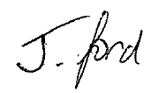
Jonathan Ford
Development Planner
Development Assessment and Certification

Senior Endorsement
The staff responsible for the preparation of the report, recommendation, or advice to any person with delegated authority to deal with the application has no pecuniary interest to disclose in respect of the application.
The staff responsible authorised to determine the application have no pecuniary interest to disclose in respect of the application. The report is enclosed and the recommendation therein adopted.
Signed
Amy Regado
Acting Chief Development Planner
Development Assessment and Certification

